A Project report on
JSON REFINER ADVANCED EDITION
Under Manonmaniam Sundaranar University
Submitted by
JENIHA J (23083300500112012)
JENISHA ANTO J (23083300500112013)
JESNI HAMIO G (23083300500112014)
KEERTHANA P (23083300500112015) LAKSHMI V (23083300500112016)


DEPARTMENT OF COMPUTER APPLICATIONS
ARUNACHALA ARTS & SCIENCE (WOMEN) COLLEGE
Manonmaniam Sundaranar University
Tirunelveli-627 001

JSON Refiner Advanced Edition
Professional JSON Processing Tool with Gradio Interface

Project Description

JSON Refiner Advanced Edition is an intelligent platform designed to simplify the process of working with JSON data. It is developed using Python’s powerful data processing capabilities and provides features such as JSON parsing, validation, transformation, and refinement. The system uses an interactive and visually appealing interface built with Gradio, making it easy for users to process and manage JSON data efficiently. The platform helps solve common issues related to JSON formatting and data quality by offering AI-based JSON generation, automatic data type detection, schema validation, case conversion, flattening and unflattening, and clean production-ready output.
The system works by analyzing unstructured key-value data and automatically identifying the correct data types, such as strings, numbers, booleans, null values, arrays, and objects. It also ensures that the JSON structure follows consistent naming styles like snake_case, camelCase, kebab-case, and PascalCase. In addition, the platform can validate JSON data using schemas and provide different transformation options to improve the structure and usability of the data.
Through its user-friendly Gradio interface, JSON Refiner Advanced Edition makes JSON processing simple, organized, and efficient. It helps users handle complex JSON transformations while maintaining data accuracy, proper validation, and high-quality output suitable for real-world applications.
Scenarios

Scenario 1: Converting CSV Data to JSON

A data analyst wants to convert a CSV file that contains mixed data types into a well-structured JSON format. The system takes key-value pairs from the CSV file, such as name: John, age: 28, active: true, score: 95.5, and automatically identifies the correct data types. It then organizes the data using consistent naming styles and produces a clean JSON output that is ready for realworld use. The analyst can also validate the generated JSON with a predefined schema to make sure the data is accurate before transferring it to a database.

Scenario 2: Standardizing API Responses

A backend developer works with JSON responses from different third-party APIs, but each API uses different key naming styles and structures. The system helps by converting all keys into a single consistent format (for example converting FirstName, first_name, and firstName into one naming style). It can also combine multiple API responses into one structured format, remove empty or null values, and check the data using a master schema. This ensures the final data is clean and ready to be used by the frontend without extra manual processing.

Scenario 3: Managing Configuration Files

A DevOps engineer often works with configuration files written in simple text format and needs to convert them into JSON for automated deployment systems. The system reads configuration values such as database_host: localhost, port: 5432, ssl_enabled: true, retry_count: 3 and automatically identifies the correct data types. It checks for required fields, prevents duplicate keys, and provides clear error messages if something is wrong. Finally, it generates valid JSON that can be easily used in infrastructure automation tools while keeping configurations easy to maintain.

Scenario 4: Flattening Data for Analysis

An analytics team sometimes receives JSON files with deeply nested structures that are difficult to analyze in spreadsheet tools. The system simplifies this by flattening the nested data. For example, a structure like user: {name: "John", profile: {age: 28}} can be converted into a flat format such as user.name: "John" and user.profile.age: 28. This makes the data easier to use in tools like CSV or Excel. When needed, the data can also be converted back to its original nested format without losing any information.

Scenario 5: Validating Data Using Schemas

A quality assurance team needs to make sure that JSON data follows company standards. The system allows them to validate JSON data using a predefined JSON Schema. It checks whether the structure and required fields are correct and provides clear error messages if there are missing or incorrect values. This process helps prevent invalid data from entering the system and ensures that all data remains consistent across different applications.

Architecture Overview

JSON Refiner Advanced is built as a modular platform combining Python backend with sophisticated JSON processing algorithms for intelligent data transformation. The architecture prioritizes data integrity, user experience, and production readiness through Gradio's interactive interface and comprehensive validation mechanisms.

Core Technologies

· Python 3.8+: Core programming language for robust data processing

· Gradio 4.0+: Interactive web interface framework for user interaction

· JSON5: Advanced JSON parsing for flexible input handling

· JSONSchema: Schema validation and data conformance checking

· Regular Expressions: Pattern matching for advanced parsing

· Google Colab: Cloud-based development and deployment environment

· HTML5/CSS3: Modern web standards for interface rendering

Pre-requisites

Software Requirements

· Python 3.8+: Download from python.org

· Google Account: Required for Google Colab access

· pip: Python package manager (comes with Python)

· Web Browser: Chrome, Firefox, Safari, or Edge
· Internet Connection: Required for Colab and Gradio sharing

Knowledge Prerequisites

· Python Basics: Functions, dictionaries, list comprehensions, string manipulation

· JSON Fundamentals: JSON structure, types, and validation

· Regular Expressions: Pattern matching for data parsing

· Gradio Framework: Understanding of interface components and callbacks

· Data Validation: Familiarity with JSON Schema and validation concepts

· Google Colab: Basic notebook interface and cell execution

Hardware Requirements

· Processor: Any modern processor (Intel i3 or equivalent)

· RAM: Minimum 2GB local (Colab provides cloud resources)

· Storage: 500MB free space for application and generated files

· Display: Minimum 1024x768 resolution for interface usability
Project Workflow

Phase 1: Environment Setup & Core Architecture

Activity 1.1: Install Dependencies & Configure Environment

· Create requirements.txt with all dependencies

· Set up Google Colab environment with proper settings

· Install required packages: gradio, json5, jsonschema, python-dotenv, pydantic

· Verify all packages are installed correctly

Activity 1.2: Design Core Data Structures

· Define CaseStyle Enum for case conversion options

· Create JSONRefinerCore class with all processing methods

· Design type inference system for automatic data type detection

· Implement error tracking and logging mechanisms

Phase 2: Core JSON Processing Engine

Activity 2.1: Implement Type Inference System
· Create infer_type() method for automatic type detection

· Handle boolean conversions (true/false, yes/no, on/off)

· Implement null value handling (null, none, nil, n/a)

· Parse numbers (integers and floats)

· Process arrays and objects from JSON strings

· Default to string for unrecognized values

Activity 2.2: Build Key Normalization & Case Conversion

· Implement to_snake_case() conversion

· Implement to_camelCase() conversion

· Implement to_kebab_case() conversion
· Implement to_pascal_case() conversion

· Create normalize_key() method that applies selected case style

· Test all case conversion combinations

Phase 3: Validation & Transformation Features

Activity 3.1: Implement JSON Schema Validation
· Create validate_json_schema() method

· Use jsonschema library for Draft7 validation

· Implement error message formatting

· Test against various schema definitions

Activity 3.2: Build Required Fields Checking

· Create check_required_fields() method

· Implement field presence validation

· Generate missing field reports

· Combine with schema validation results

Activity 3.3: Develop JSON Transformation Methods

· Implement flatten_json() for nested to flat conversion

· Implement unflatten_json() for dot-notation reversal

· Create merge_json_objects() for deep merging

· Implement remove_null_values() for data cleanup

· Test all transformation methods with complex data

Phase 4: Gradio Interface Development

Activity 4.1: Design Core Refining Tab
· Create input fields for key-value text

· Add case style radio button selector
· Implement remove nulls and flatten checkboxes

· Build JSON output code display

· Add status and statistics output panels

Phase 5: Integration, Testing & Deployment

Activity 5.1: Google Colab Deployment
· Connect all interface tabs

· Test data flow between components

· Verify transformation pipeline

· Test error handling

Activity 5.2: Comprehensive Testing

· Test all case conversion styles

· Validate type inference accuracy

· Test schema validation with various schemas

· Test merging with conflicting keys

· Test flattening with deeply nested objects
Technical Architecture

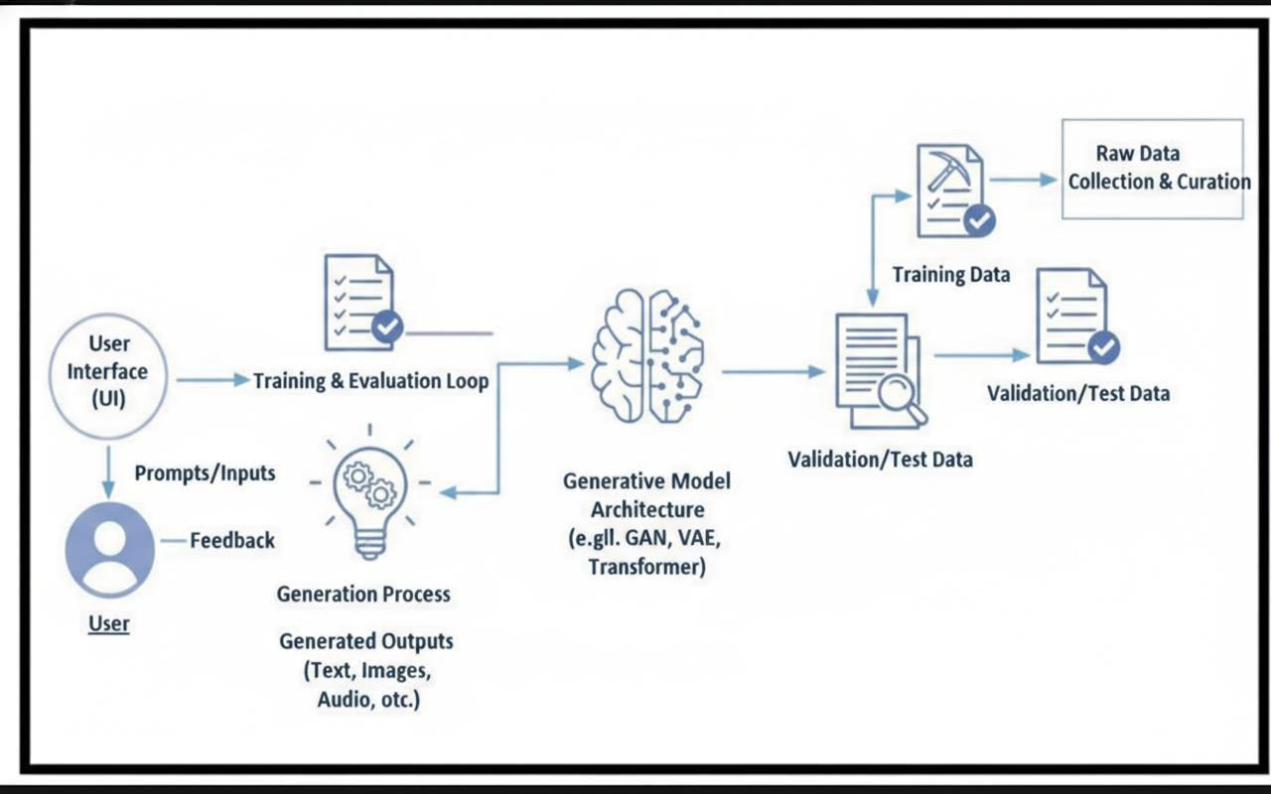

Project Structure

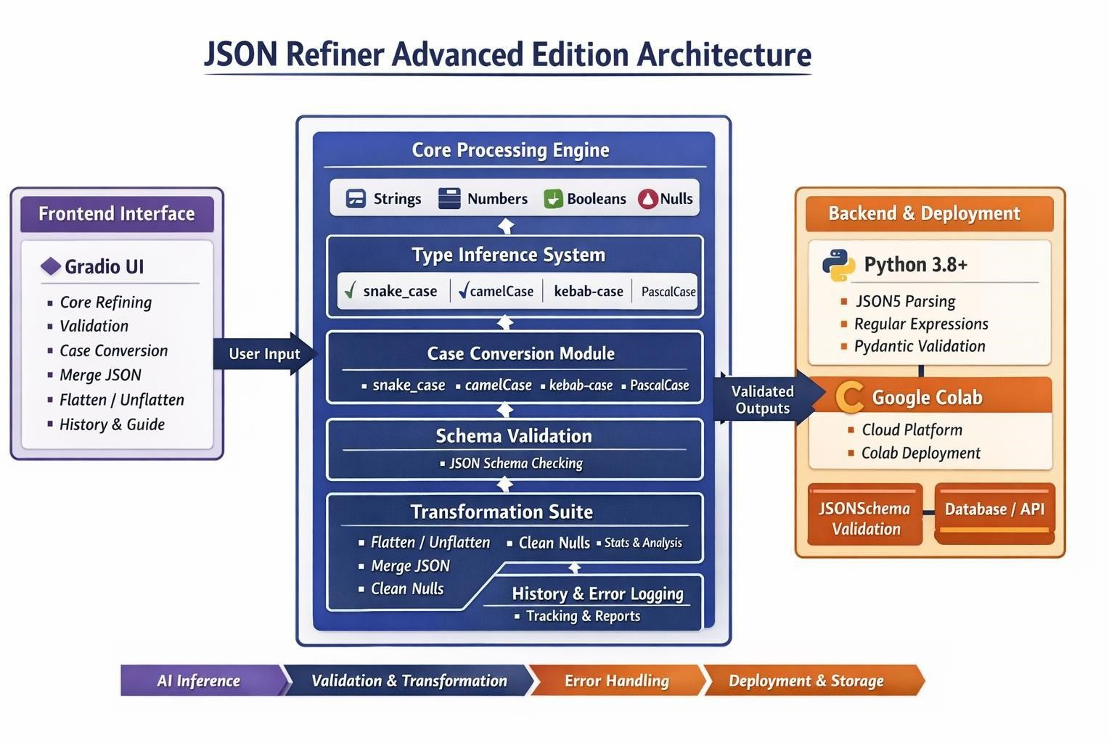
MILESTONE 1: Environment Setup & Core Architecture

Activity 1.1: Install Dependencies
Load the model :
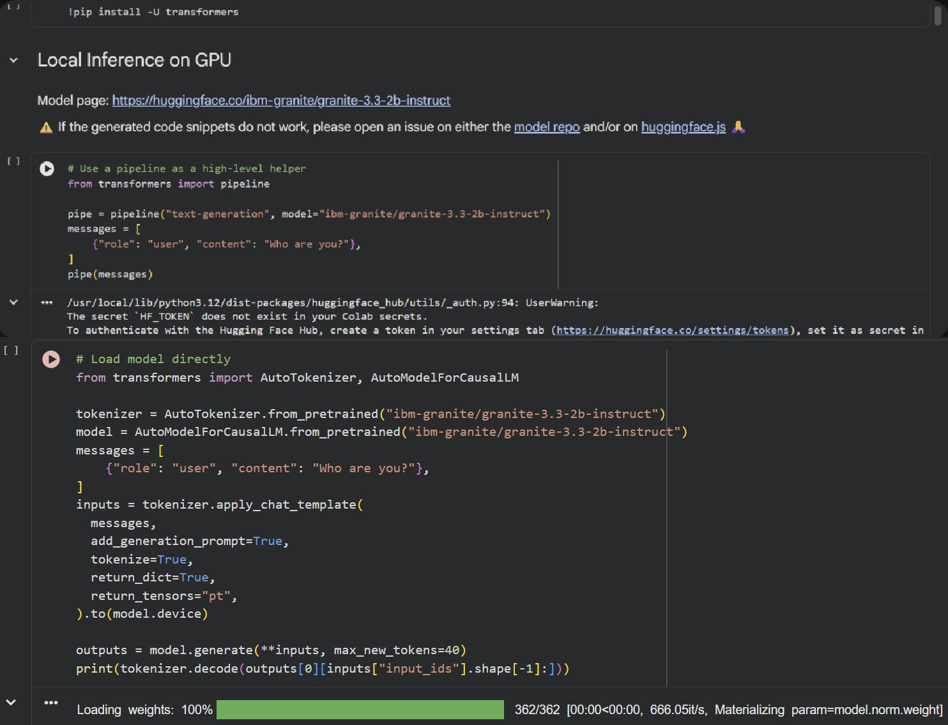

Create requirements.txt with the following dependencies:

- gradio==4.0+
- json5==0.9.6+
- jsonschema==4.17.0+
- python-dotenv==0.19.0+
- pydantic==1.9.0+
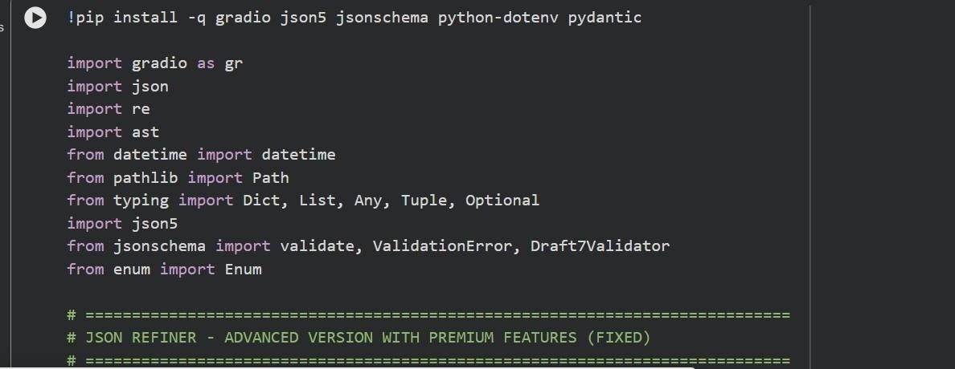

Activity 1.2: Initialize Enum and Core Class

Create CaseStyle Enum:

class CaseStyle(Enum):
SNAKE_CASE = "snake_case" CAMEL_CASE = "camelCase"
KEBAB_CASE = "kebab-case"
PASCAL_CASE = "PascalCase" Initialize JSONRefinerCore class with tracking:
class JSONRefinerCore:
def init (self):
self.conversion_log = [] self.validation_errors = [] self.transformation_history = []
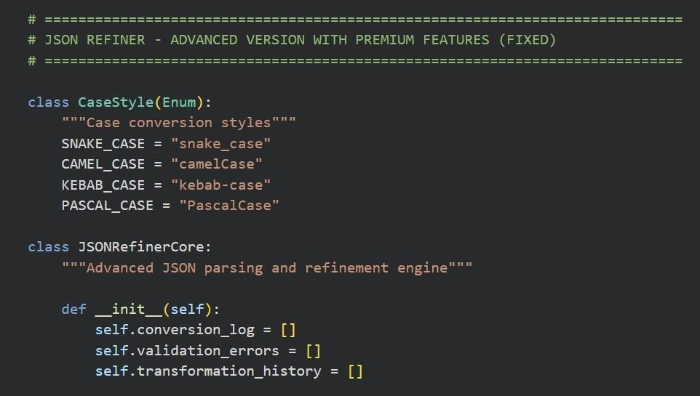

MILESTONE 2: Type Inference & Case Conversion System

Activity 2.1: Implement Type Inference

The type inference system automatically detects and converts values:

- Booleans: Recognizes true, false, yes, no, on, off, 1, 0
- Nulls: Handles null, none, nil, undefined, n/a
- Numbers: Detects integers and floating-point numbers
- Arrays: Parses JSON arrays from string format
- Objects: Parses JSON objects from string format
- Strings: Default fallback for unrecognized values

Example: "age: 28" → {"age": 28} (integer)
Example: "active: true" → {"active": true} (boolean)
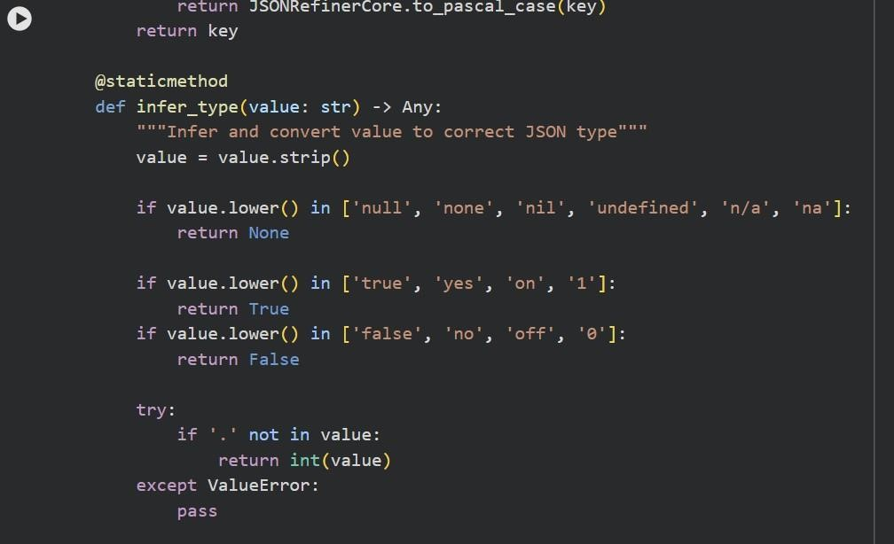

Activity 2.2: Build Case Conversion Methods

Implement four case conversion standards:

- snake_case: user_name, first_name, is_active
- camelCase: userName, firstName, isActive
- kebab-case: user-name, first-name, is-active
- PascalCase: UserName, FirstName, IsActive

Each method uses regex patterns to normalize input: - Remove non-alphanumeric characters
- Split on boundaries (spaces, underscores, hyphens)
- Apply case transformation
- Validate output format
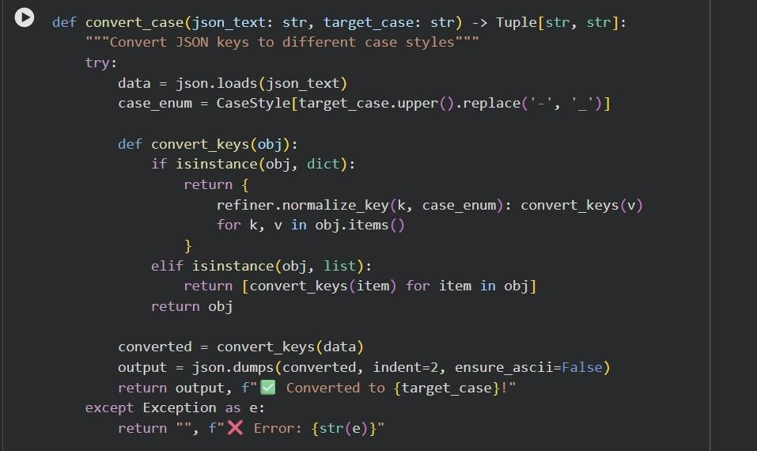

MILESTONE 3: Validation & Transformation Features

Activity 3.1: JSON Parsing & Validation
Key-value parsing system:

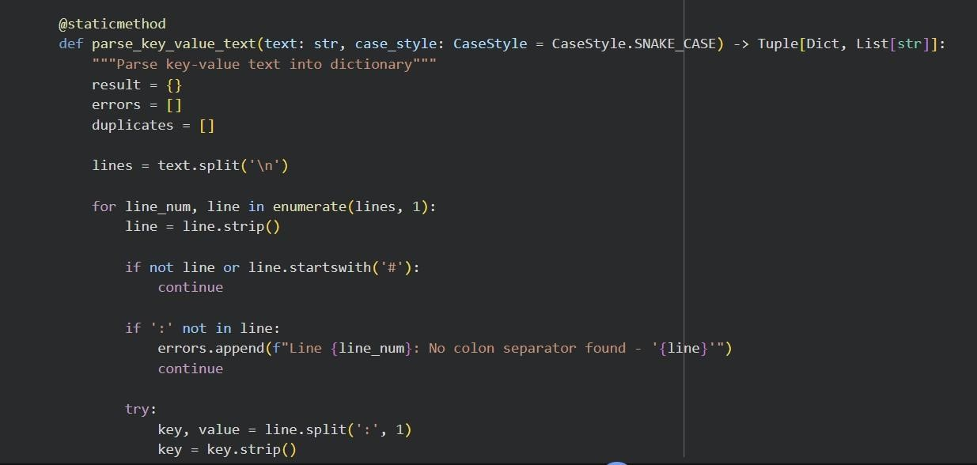
Activity 3.2: Schema & Field Validation

Dual validation approach:

1. Required Fields: Check for mandatory fields
- Input: "name, age, email"
- Result: Lists missing fields

2. Schema Validation: Validate against JSON Schema
- Input: {"type": "object", "properties": {...}}
- Result: Full structural validation - Supports Draft 7 standard
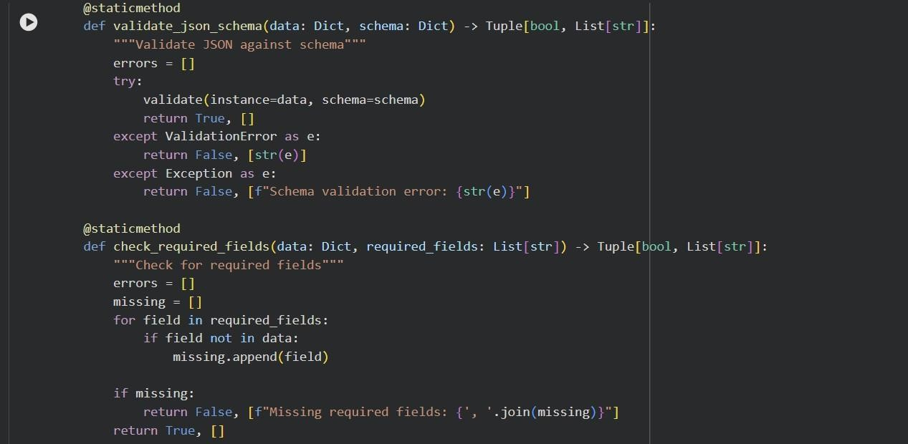

Activity 3.3: JSON Transformation Operations

Multiple transformation capabilities:

- Flatten: Convert nested objects to dot-notation Input: {"user": {"name": "John", "age": 28}}
Output: {"user.name": "John", "user.age": 28}

- Unflatten: Reverse flattening
Input: {"user.name": "John", "user.age": 28}
Output: {"user": {"name": "John", "age": 28}}

- Merge: Deep merge multiple JSON objects
- Clean: Remove null/undefined values
- Stats: Generate detailed statistics
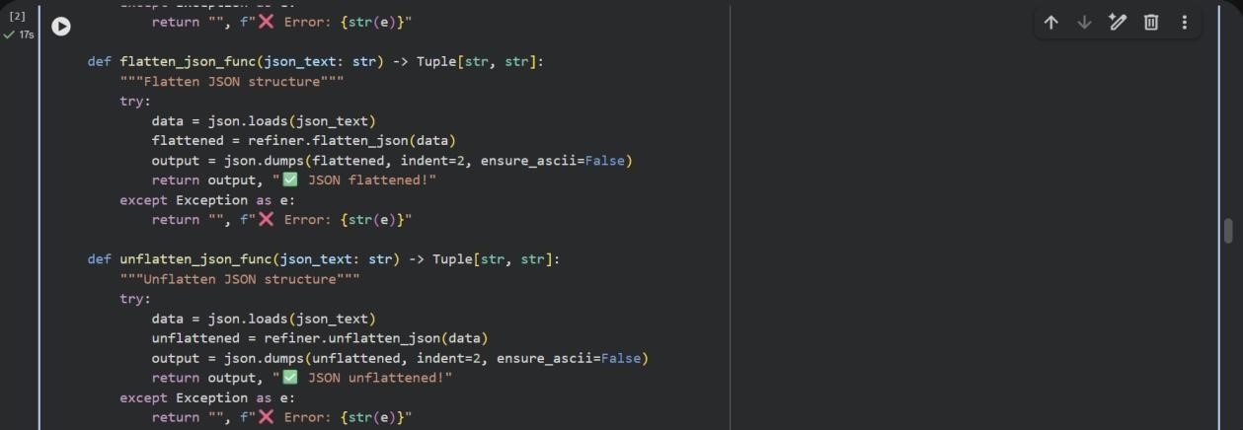

MILESTONE 4: Gradio Interface Development

Activity 4.1: focuses on designing and implementing a comprehensive multi-functional JSON refinement interface that enables users to validate, transform, analyze, and manage JSON data efficiently through an intuitive tab-based UI.
The Gradio interface includes 7 functional tabs:

1. Core Refining: Convert key-value text to JSON
- Input: Text with key-value pairs
- Options: Case style, remove nulls, flatten - Output: JSON code, status, statistics
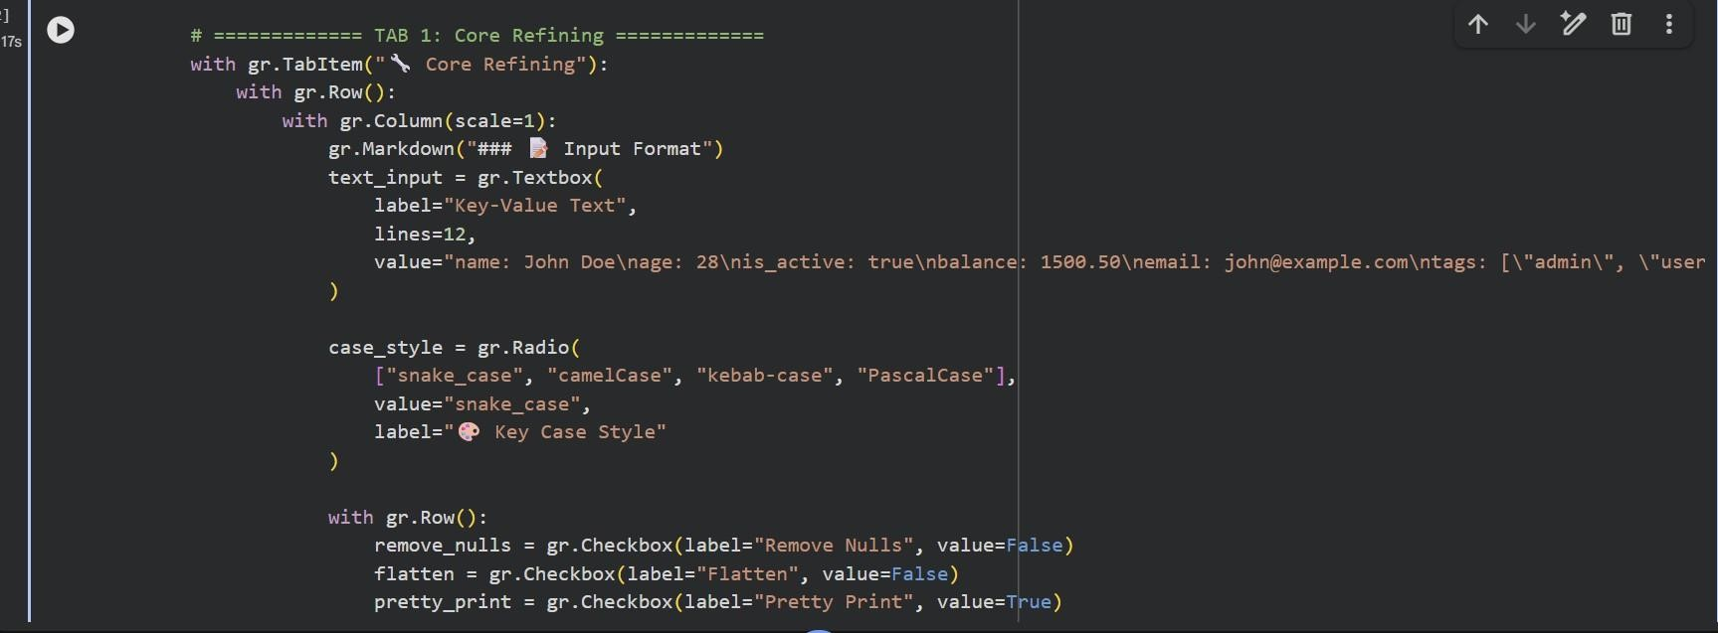

2. Validation: Validate JSON structure
- Input: JSON, schema, required fields
- Output: Validation results
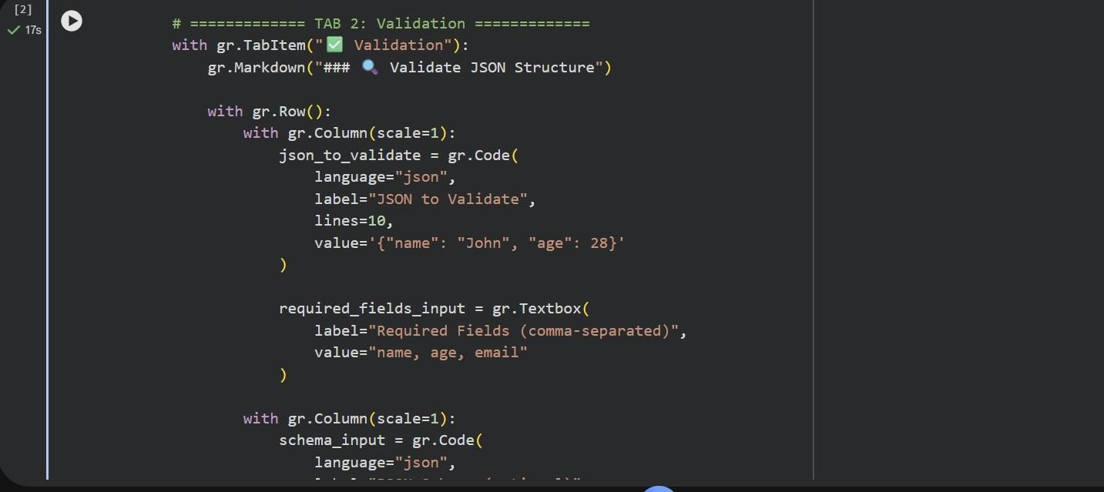

- Case Conversion: Convert between case styles
  - Input: JSON
  - Output: Converted JSON in target case
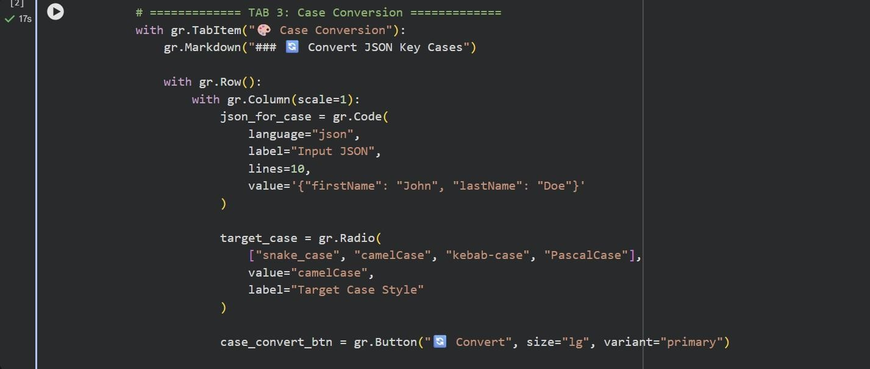

- Merge JSON: Combine multiple objects
  - Input: Three JSON objects
  - Output: Merged result
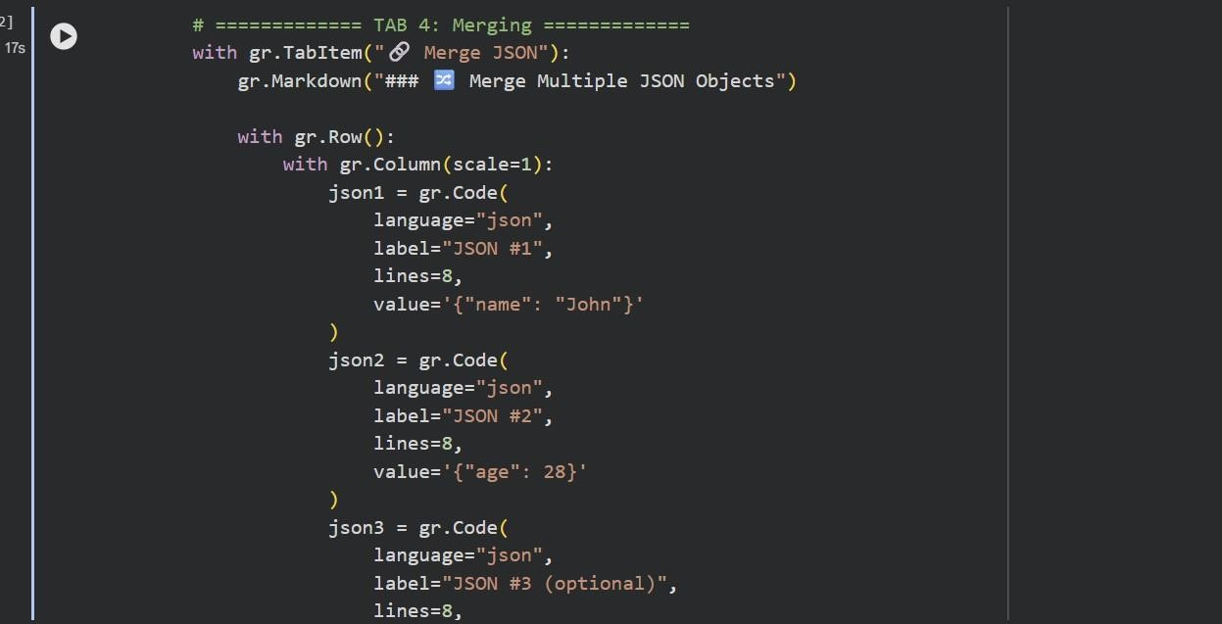

- Flatten/Unflatten: Transform nesting
- Input: JSON
- Output: Transformed structure

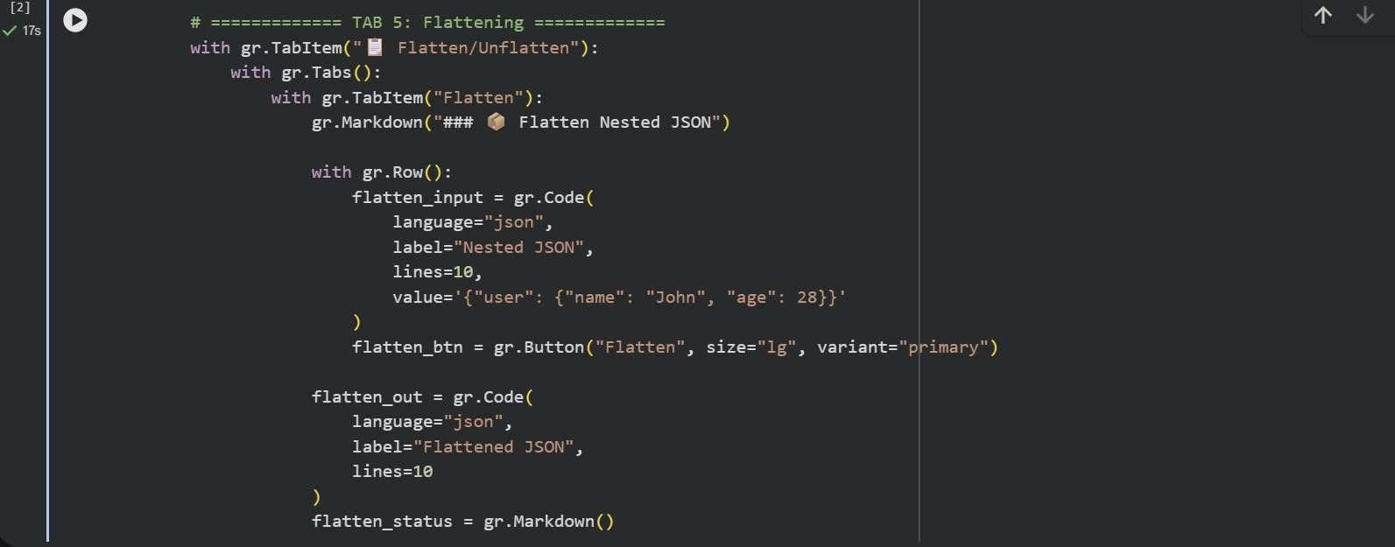

6. History: Track transformations
- Download: Export history report
- Clear: Reset history
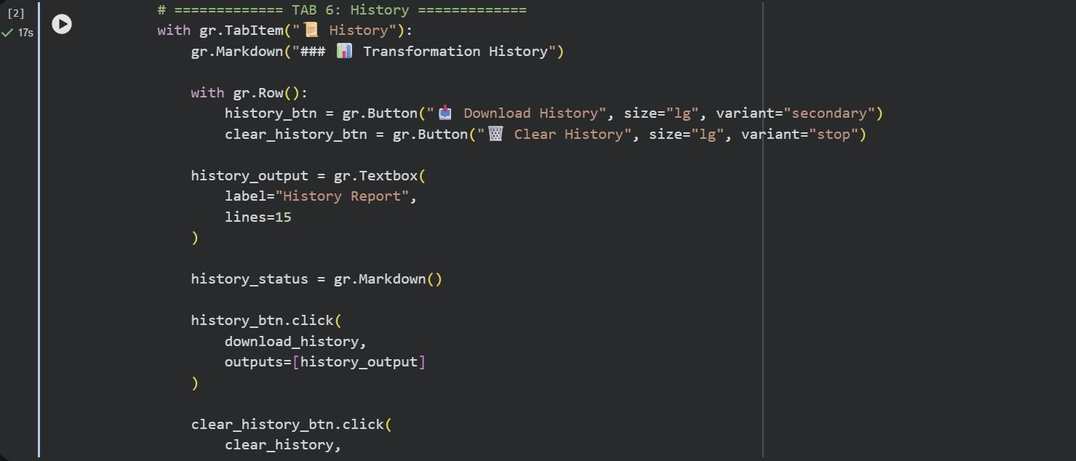

7. Guide: User documentation
- Examples, tips, and troubleshooting

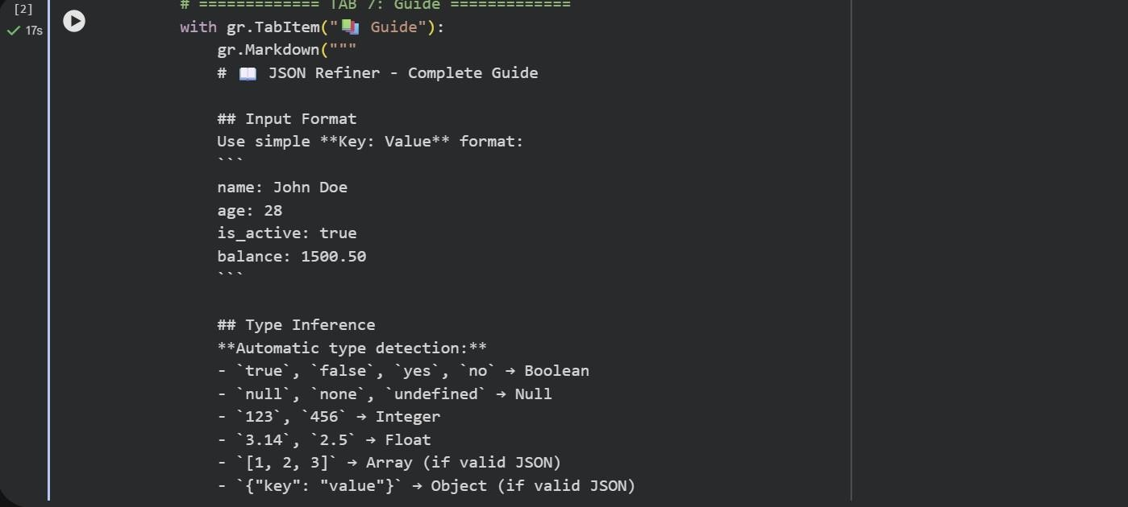

UI/UX Features

Professional interface design:

- Light theme background
- Color-coded status messages (⬛ success, + error)
- Syntax-highlighted code blocks
- Real-time processing with instant feedback
- Detailed error reporting with line numbers
- Responsive layout for various screen sizes
- Intuitive button-based navigation
MILESTONE 5: Testing & Deployment

Activity 5.1: Google Colab Deployment

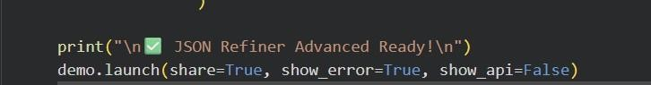

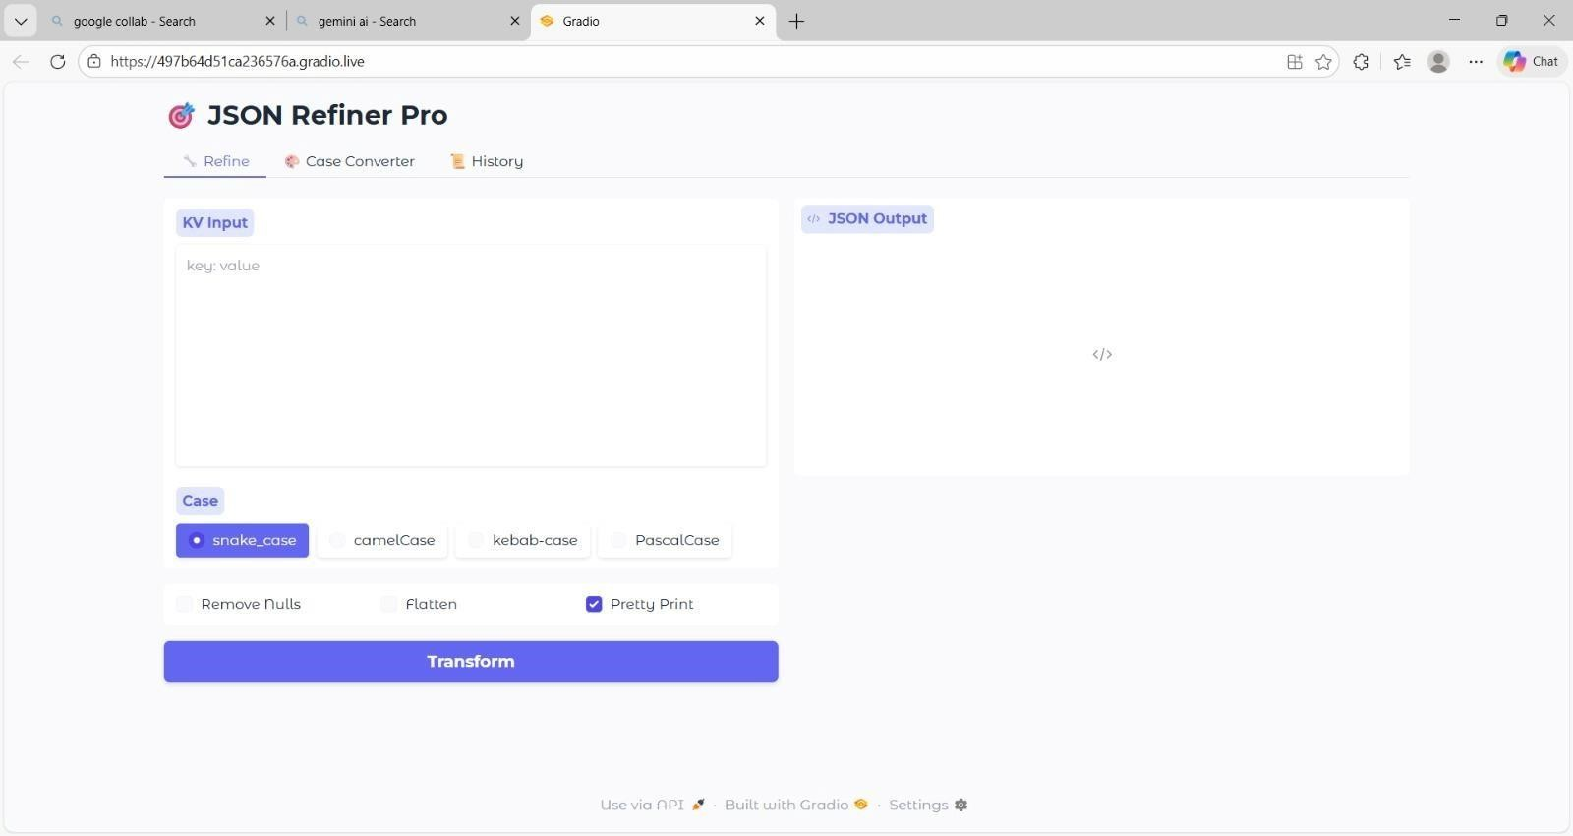

Activity 5.2: Functional Testing

Test Case 1: Basic Key-Value Conversion

Input: name: Karthick age: 25 is student: true
hobbies: coding, gamming address: null

input:
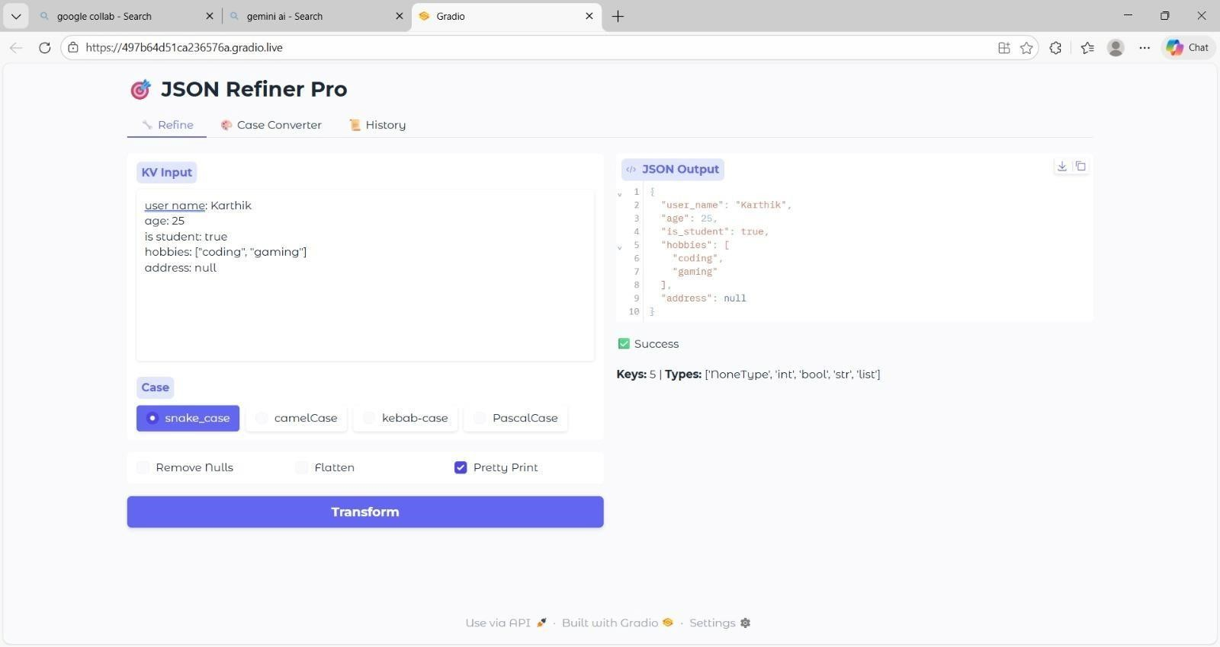

Out put :


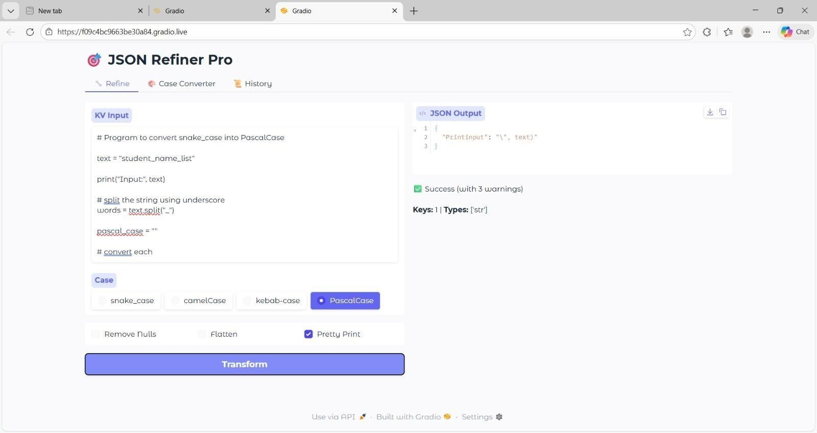

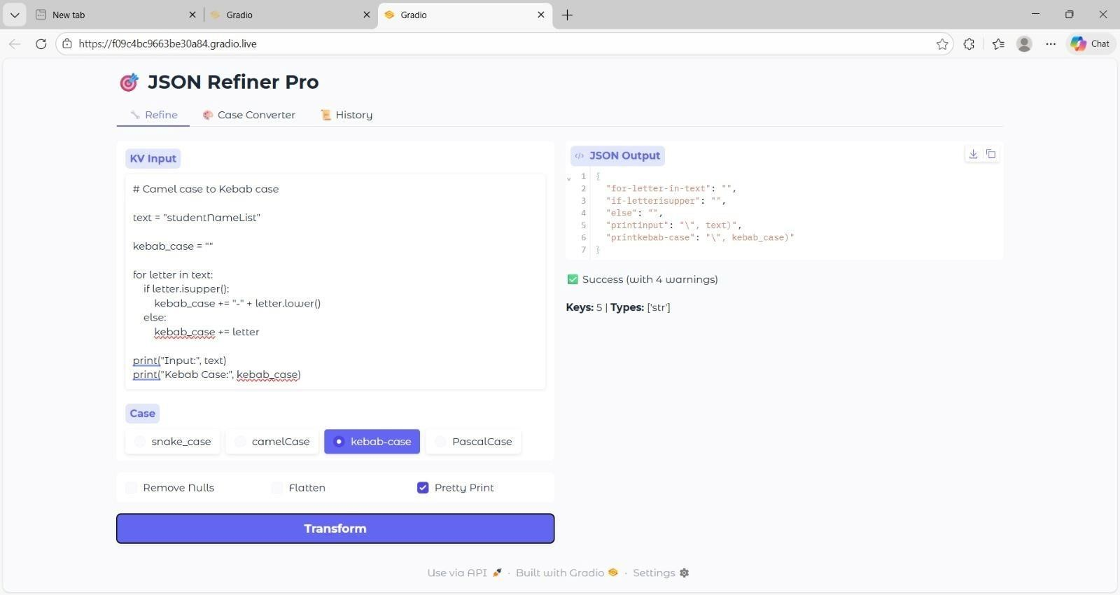
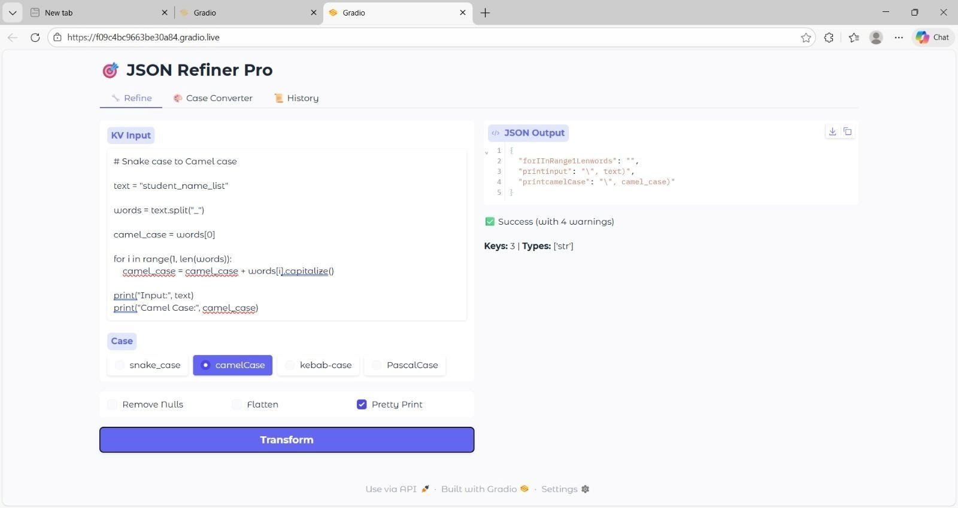

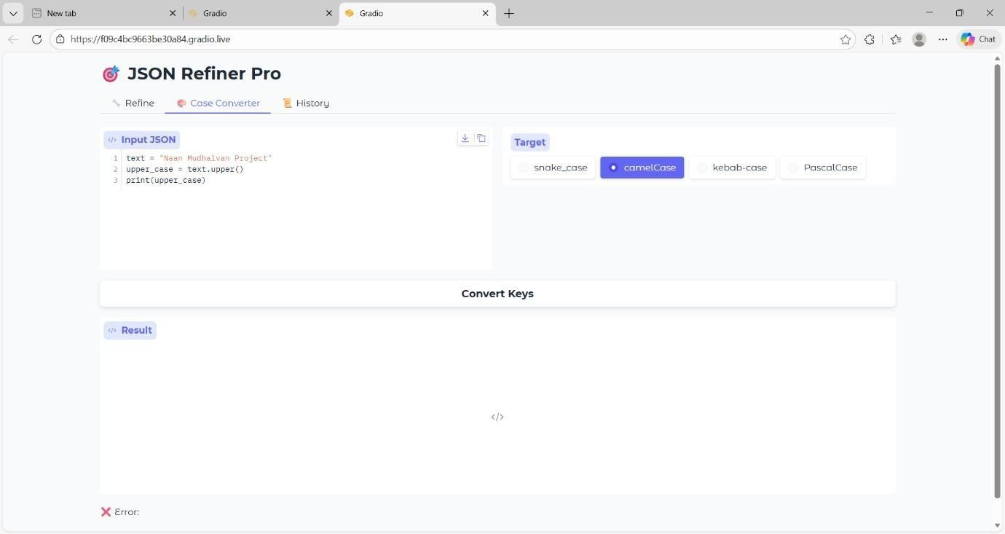
Conclusion
JSON Refiner Advanced Edition successfully functions as an intelligent JSON processing tool that combines simple data transformation with the strong data handling capabilities of Python. By using Gradio’s interactive interface and the cloud environment of Google Colab, the system provides a fast, efficient, and user-friendly way to process JSON data. This makes the platform useful not only for developers but also for data analysts and even users who may not have strong technical knowledge.
The platform shows how AI-assisted data transformation can simplify JSON processing while still maintaining high data quality. It supports features such as automatic data type detection, multiple case conversion styles, advanced transformation operations, detailed validation, and history tracking. These features help users handle complex JSON data easily and produce accurate, clean, and production-ready outputs.
Future Enhancements
The system is built with a modular design, which makes it easy to expand with additional features in the future. Possible improvements include adding custom transformation rules, regex-based data extraction, integration with popular data analysis tools like Pandas and NumPy, batch processing, API endpoint generation, and the ability to create custom validation rules. Template-based transformations and support for additional naming styles can also be introduced.
In the future, the platform could also include machine learning-based type detection, data anonymization features, and integration with cloud storage services to handle large datasets more effectively.
With further development, JSON Refiner Advanced Edition has the potential to grow into a complete data processing platform that supports multiple data formats while continuing to focus on simplicity, accuracy, and a smooth user experience.
.

